Process for Electric connection application for Newly proposed 4 G Towers under Nashik SSA

Data / Documents Required for application :

1. Land 7 /12 / Land Allotment letter : Memory Less than 300 KB
2. I Card Scan copy of Concern Site Incharge : Memory Less than 300 KB
3. BSNL PAN CARD NO. AABCB5576G
4. BSNL GST NO. 27AABCB5576G1ZL
5. BSNL Company Registration Certificate No. 271 / 2009 Dt: 08.07.2009
6. Nearest Consumer Number : [063520194012]

* Create Email ID for individual site for registration at Maitri web site : <https://maitri.mahaonline.gov.in/Registration/Registration>
* 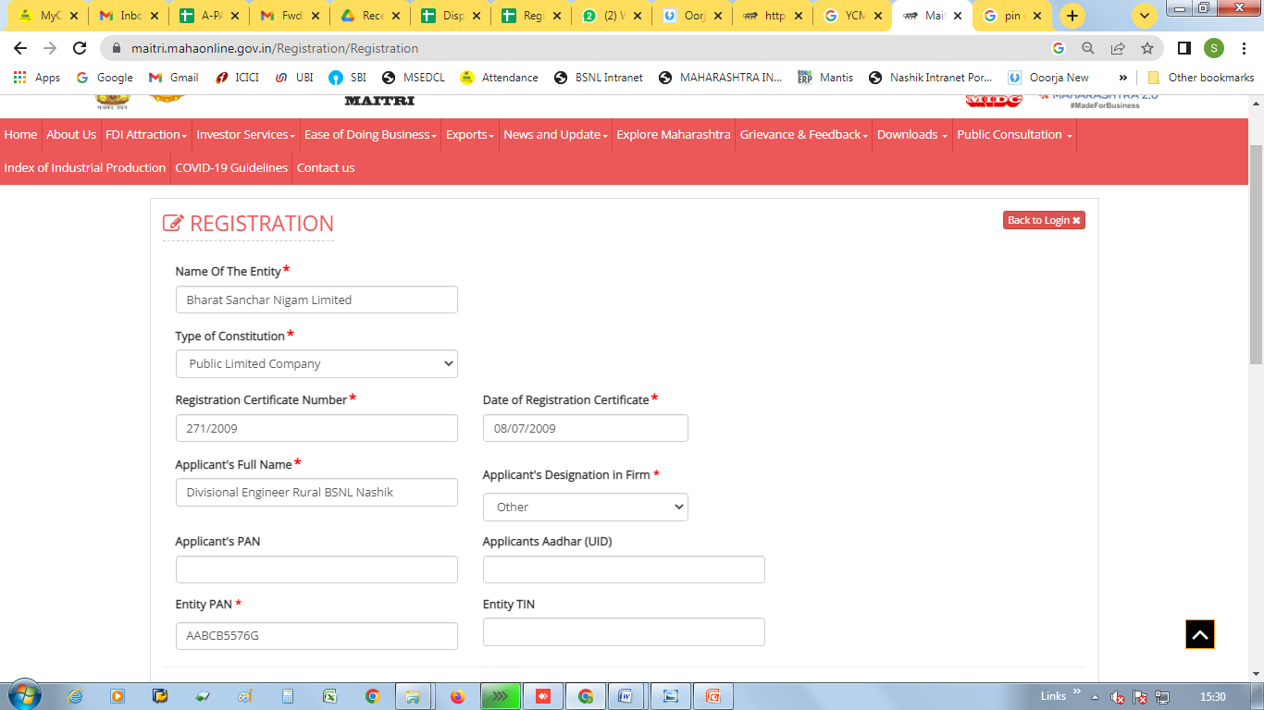
* Address and PIN CODE of 4 G Location
* Email ID : [osderuralnsk@gmail.com](mailto:osderuralnsk@gmail.com)
* Mobile No. 9423967222
* User Name : Ubhidhond46
* Password : Ubhidhond@2023
* 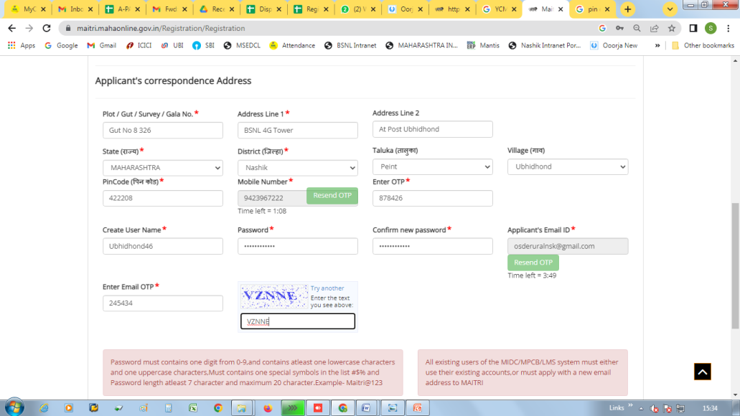
* Login to Maitri Web site with created user / registration ID
* 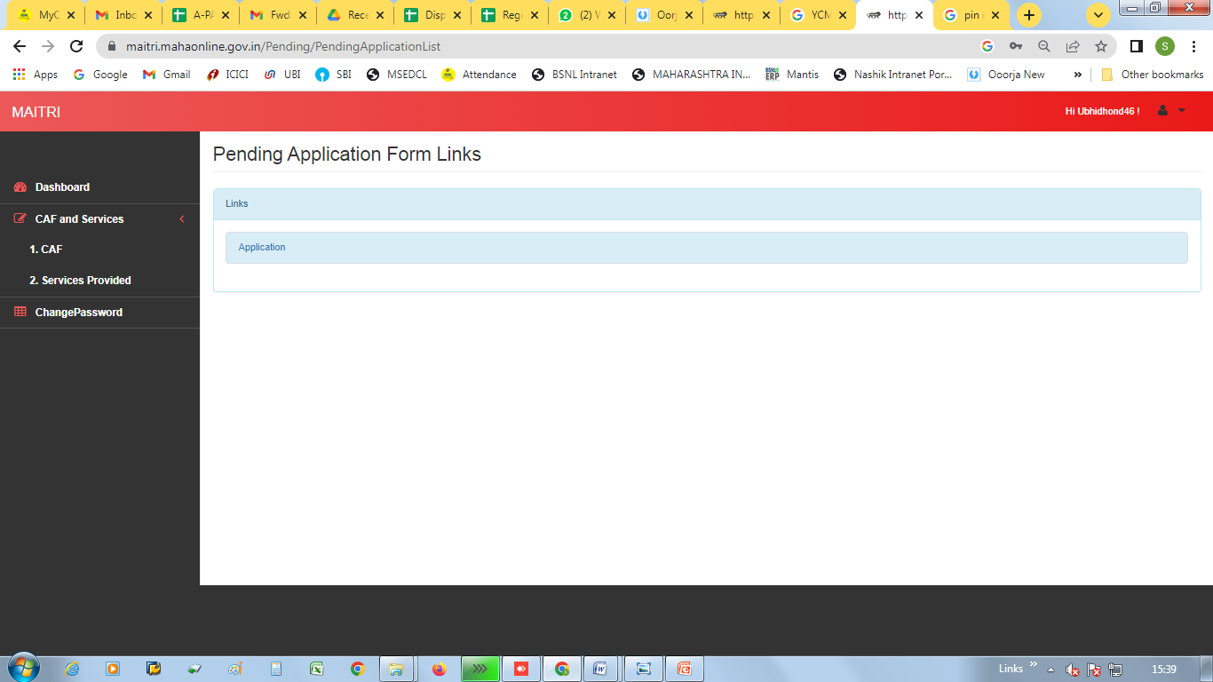
* Click on the CAF, after that following window will open
* 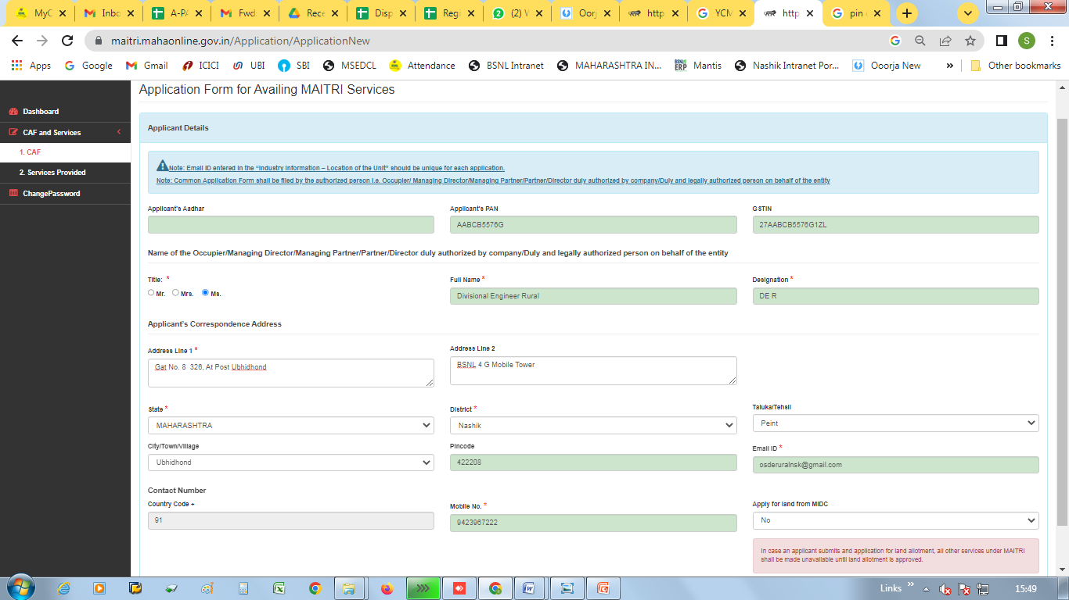
* Click on to Move to next stage
* 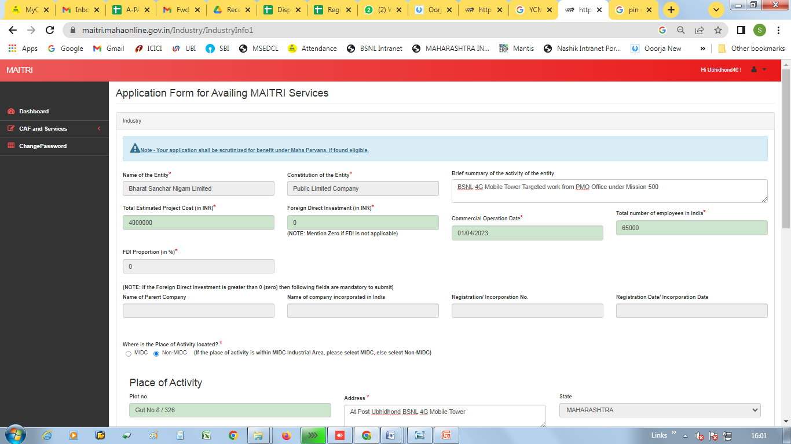
* Click on to Move to next stage
* 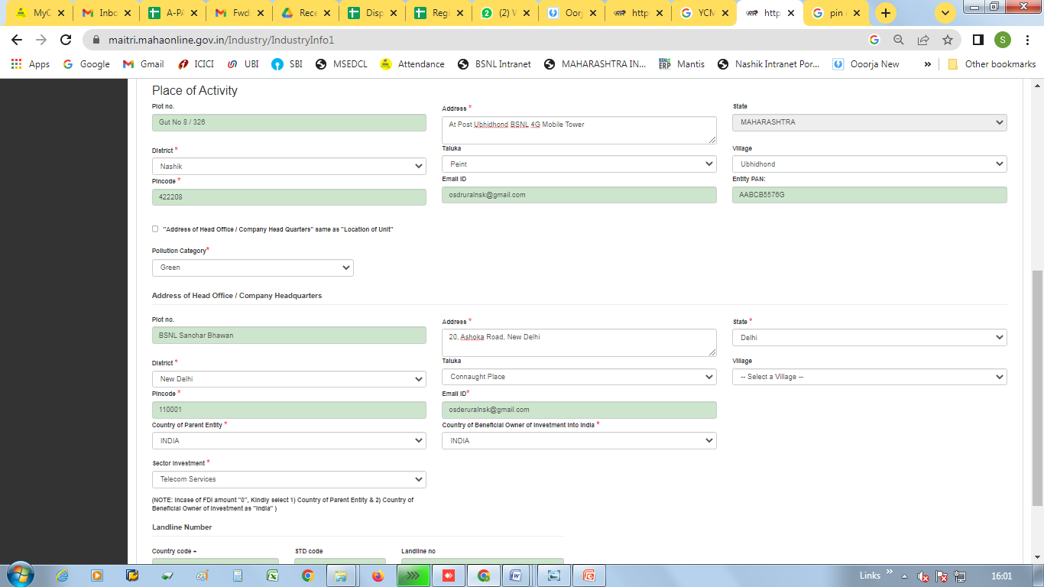
* 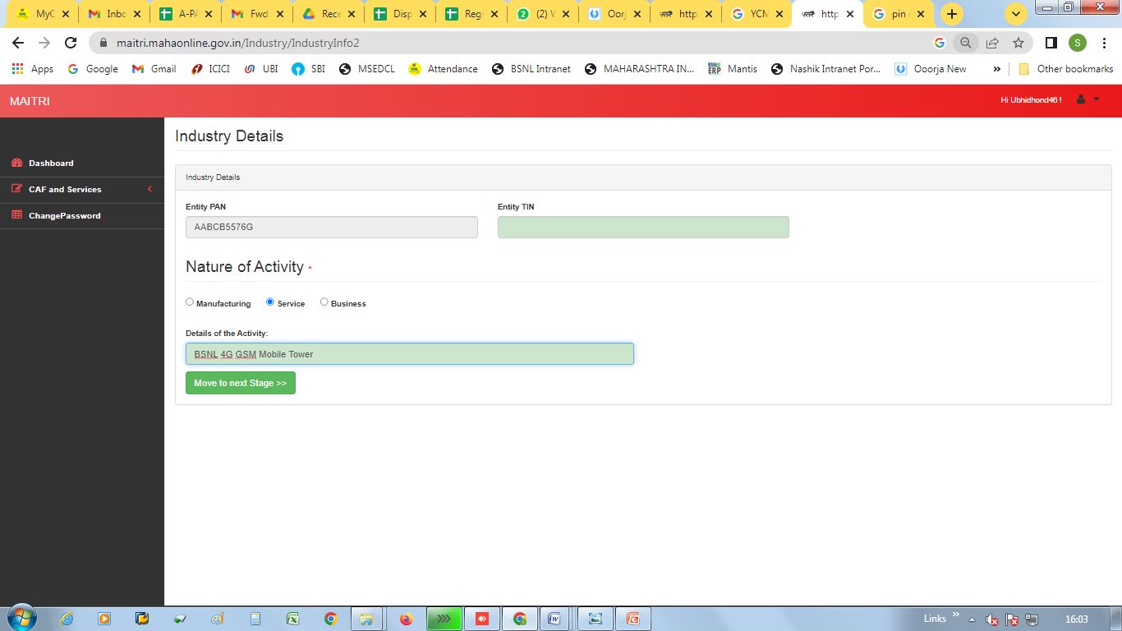
* Click on to Move to next stage
* 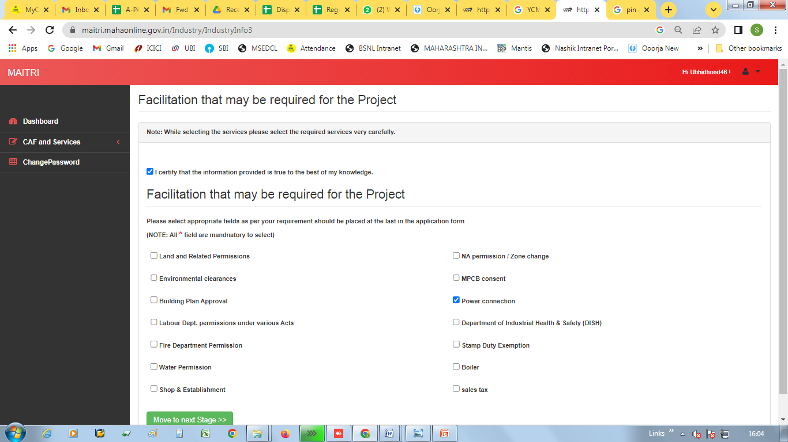
* Use Website for compress the Document size : https://bigpdf.11zon.com/en/compress-pdf/

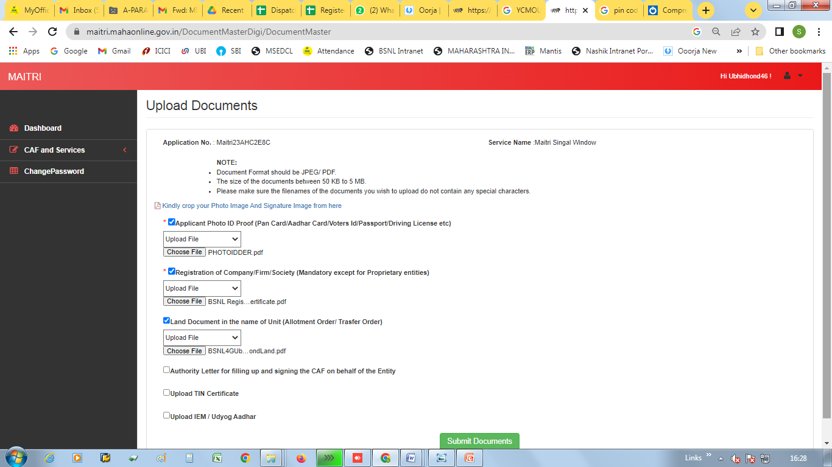

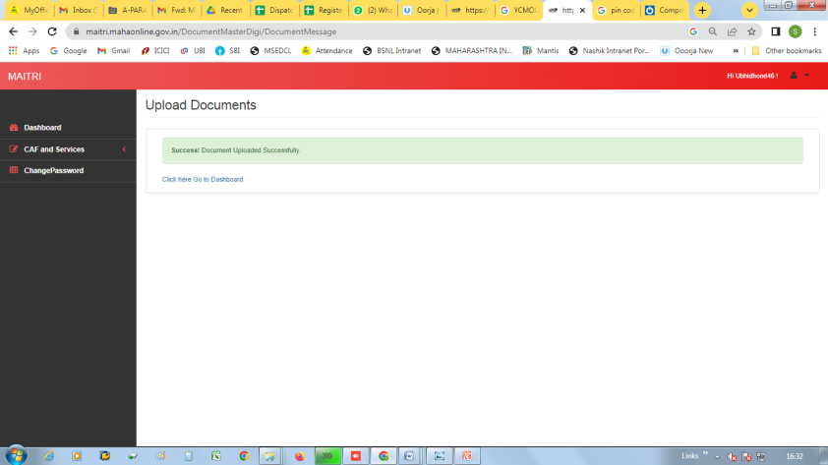

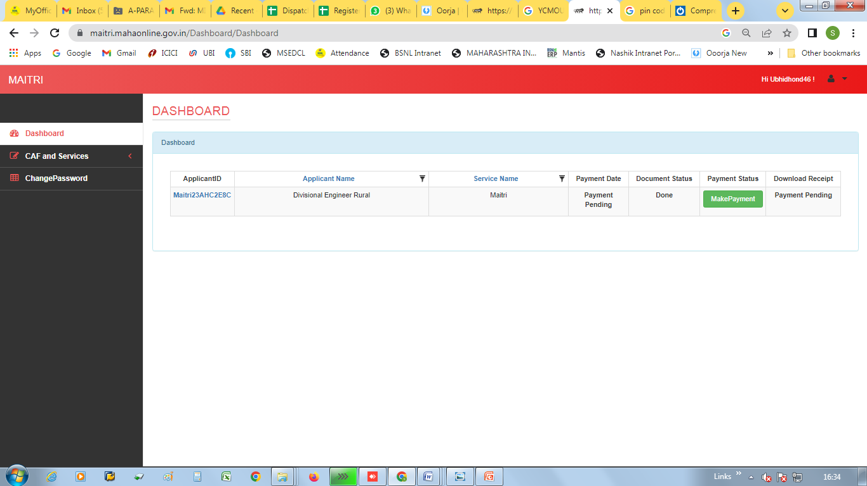

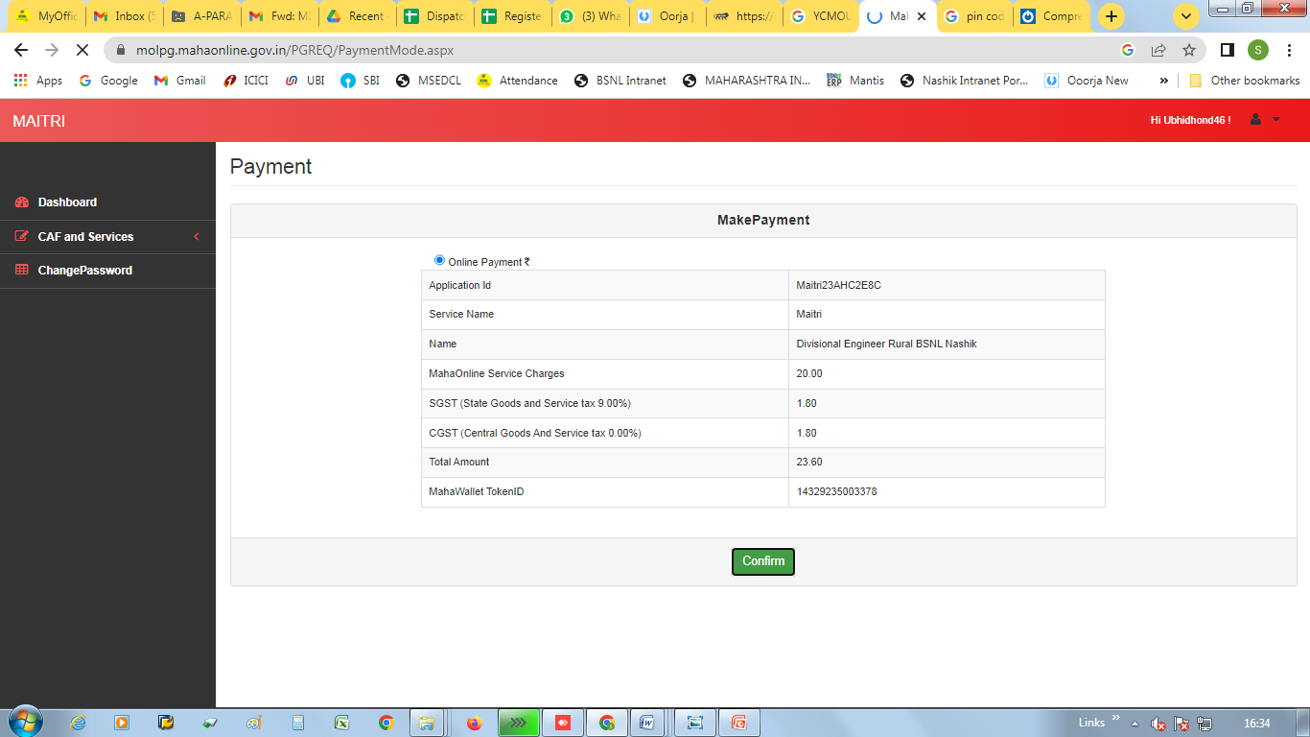

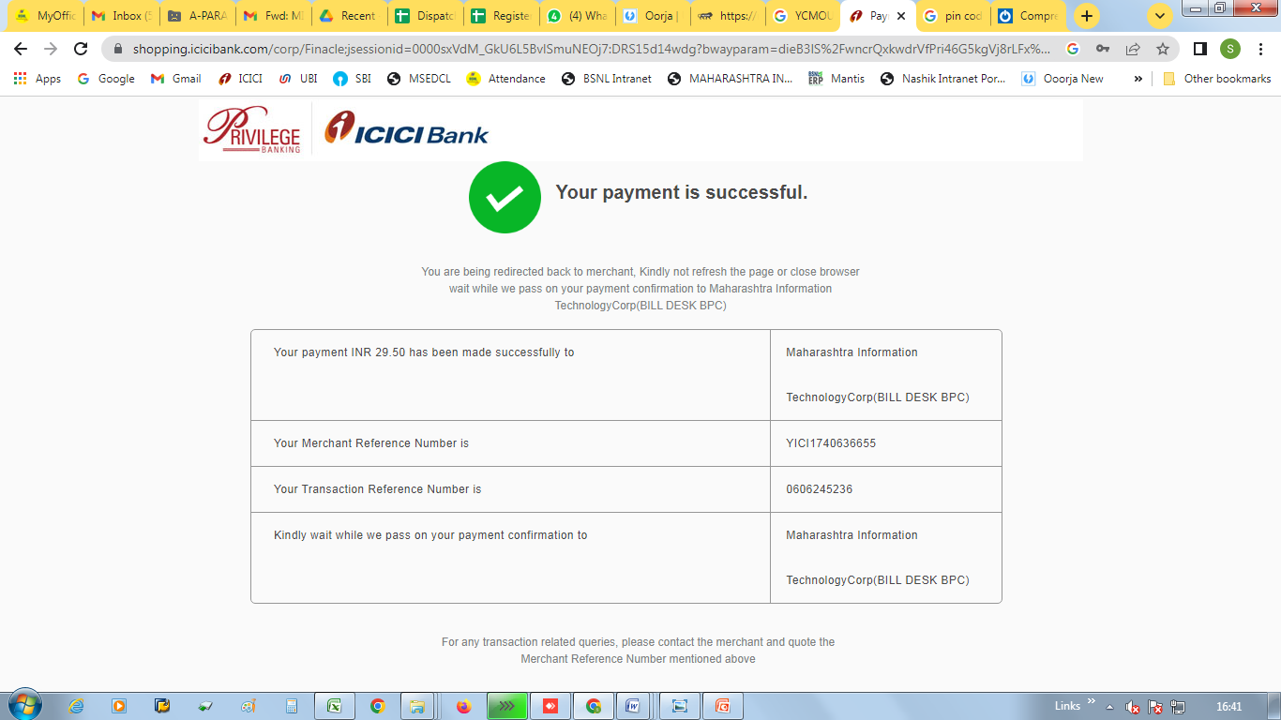

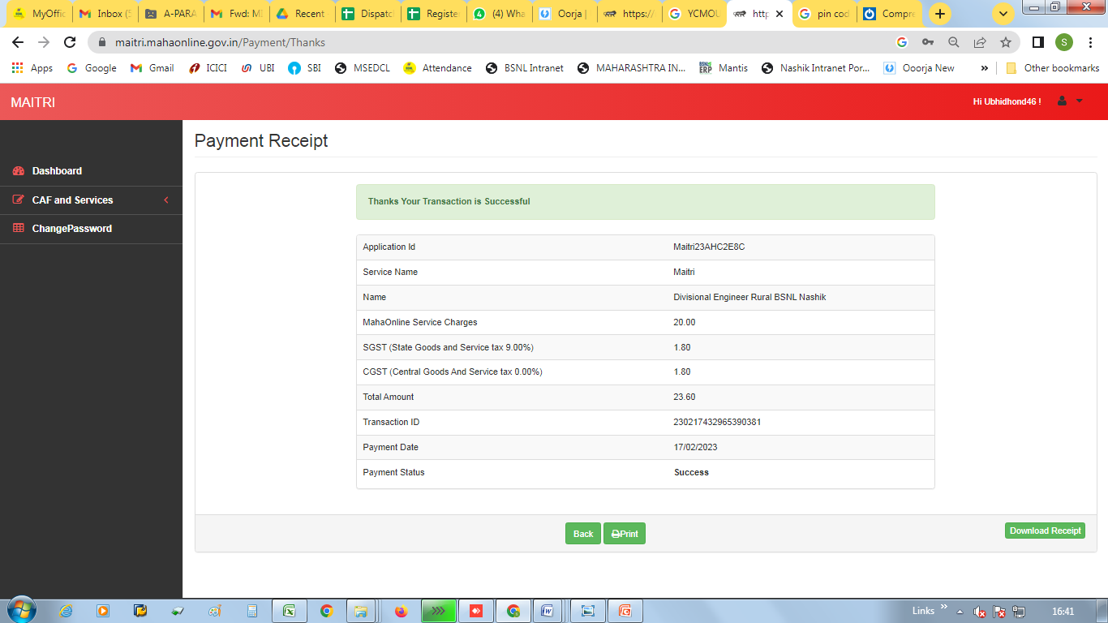

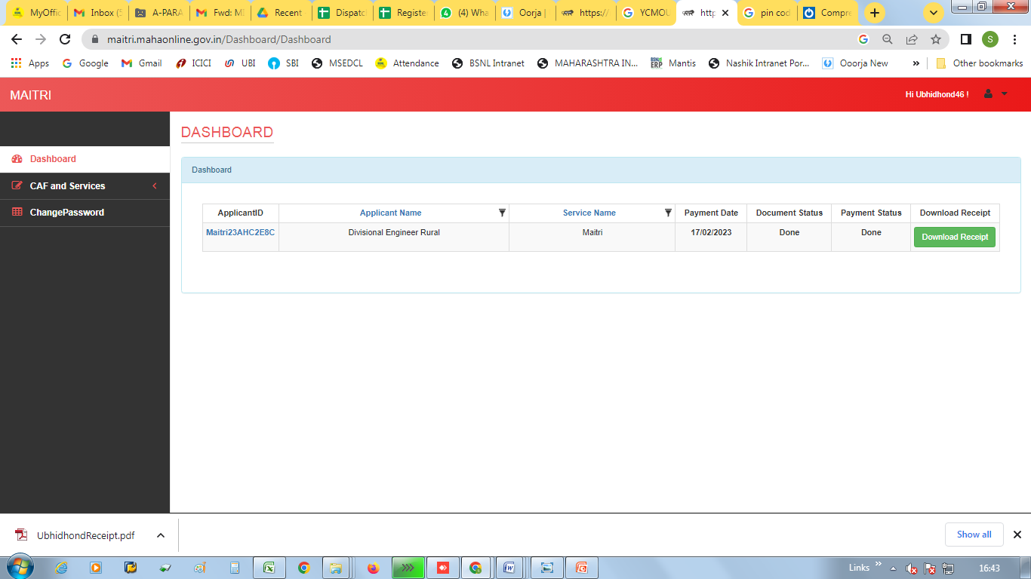

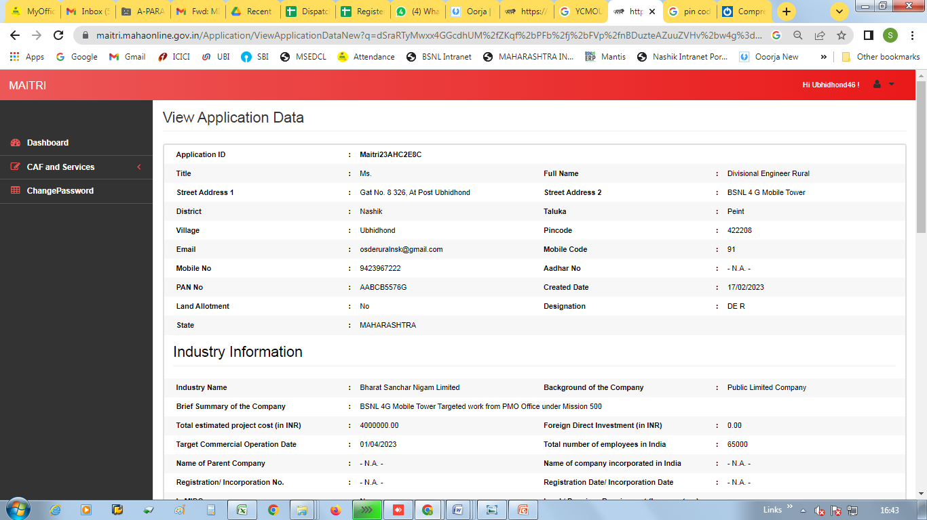

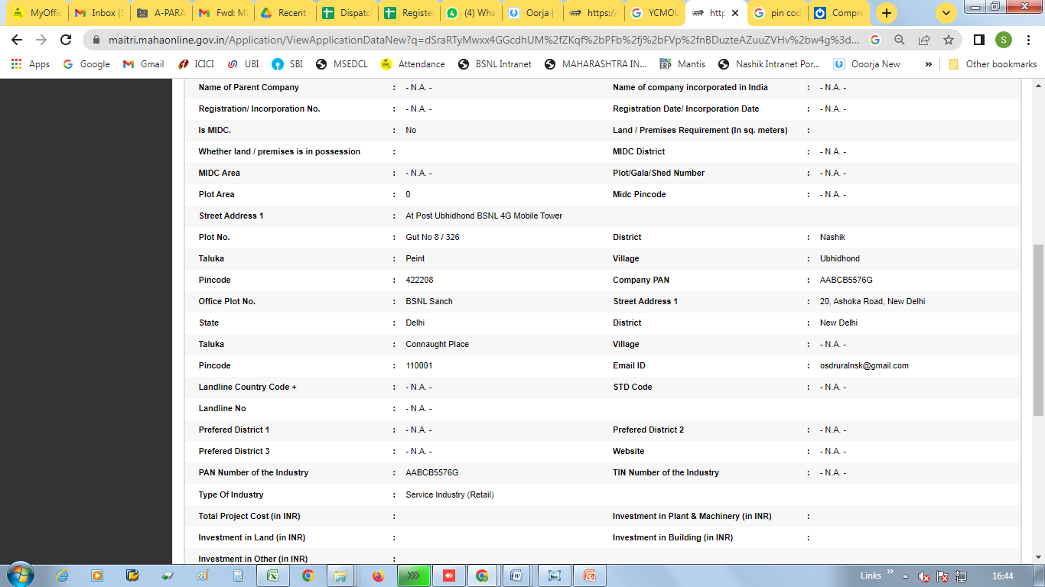

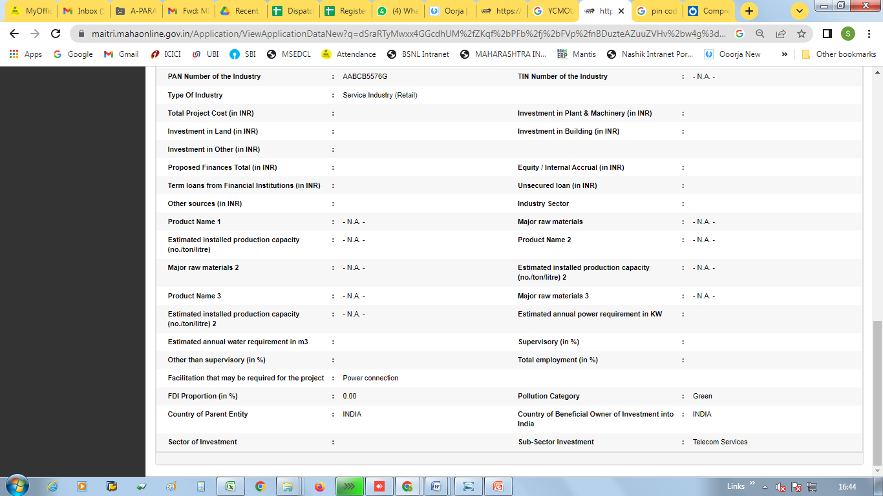

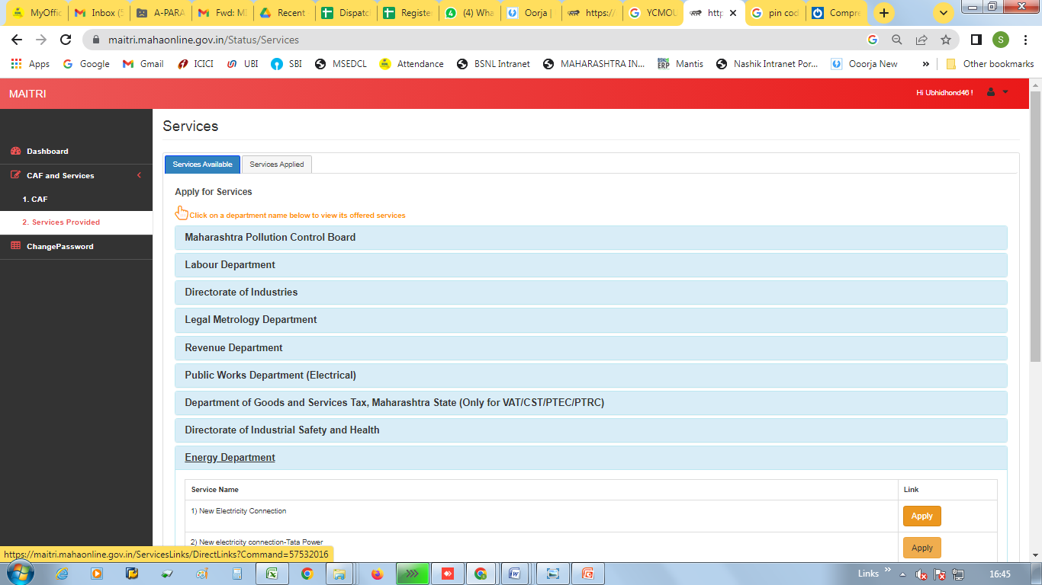

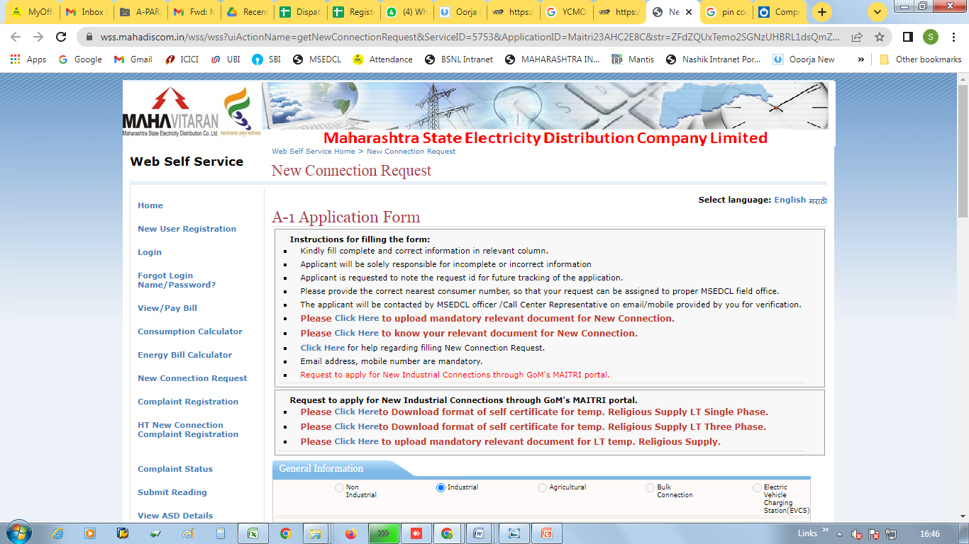

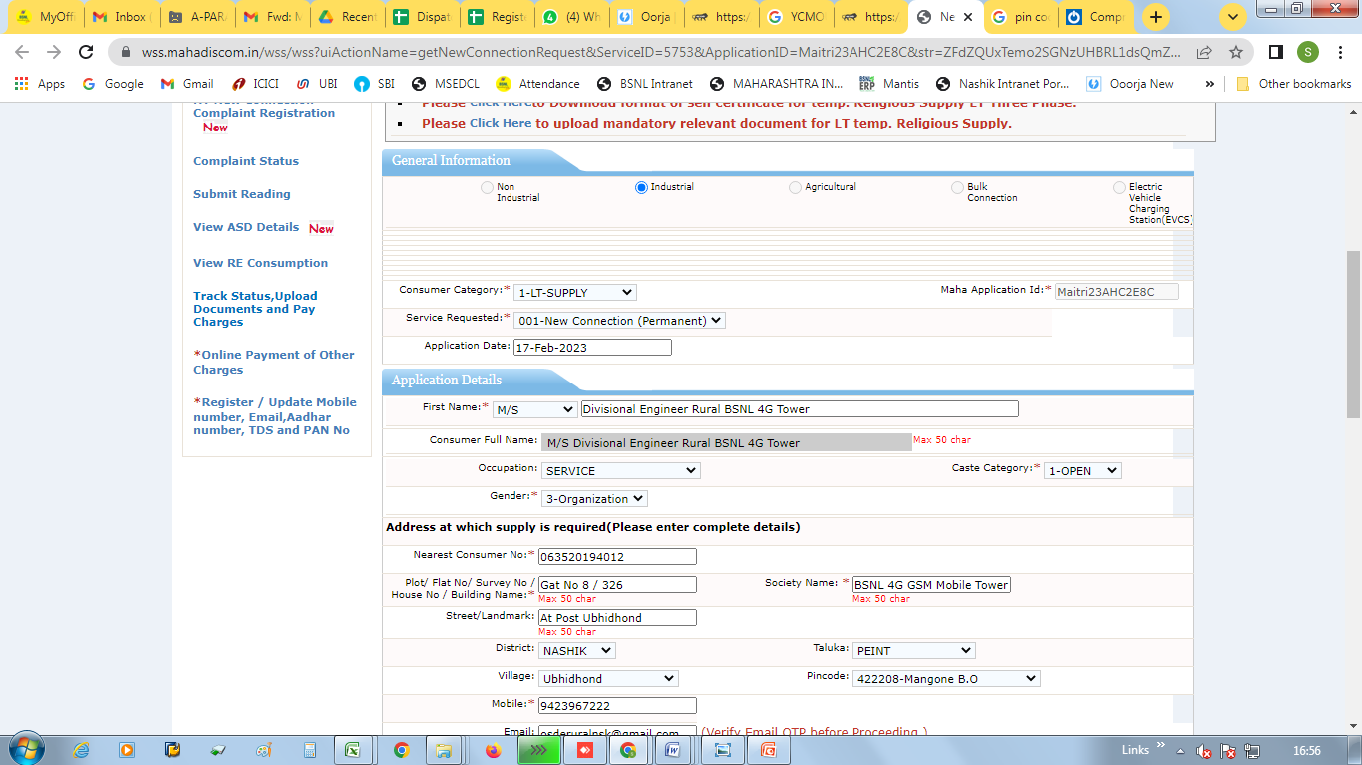

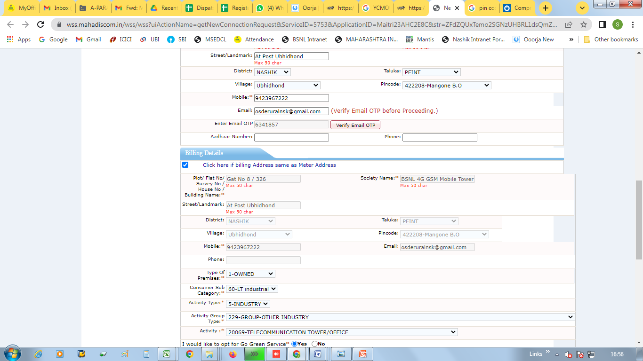

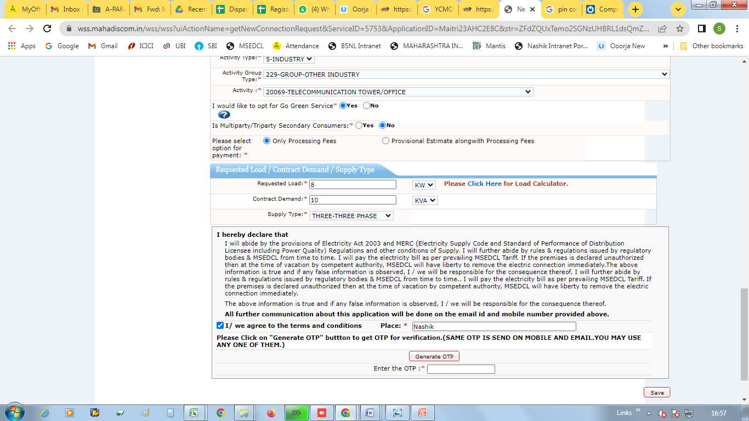

Application ID : 47465921

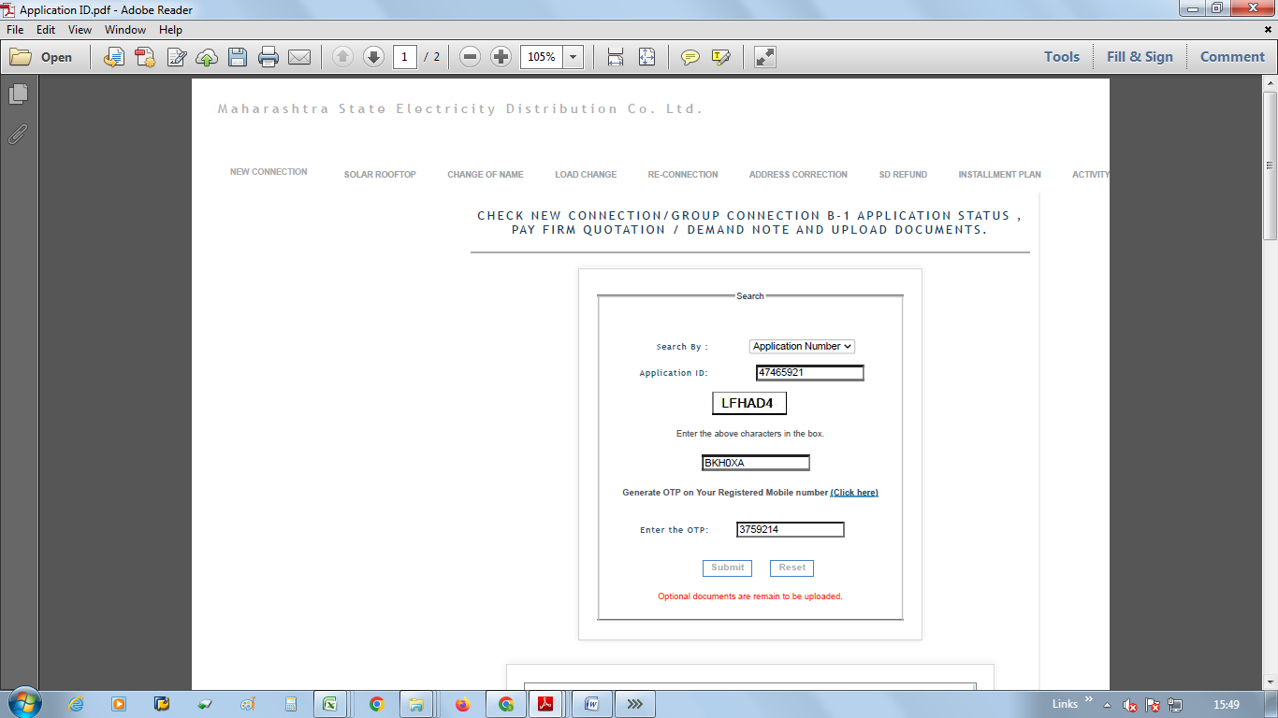

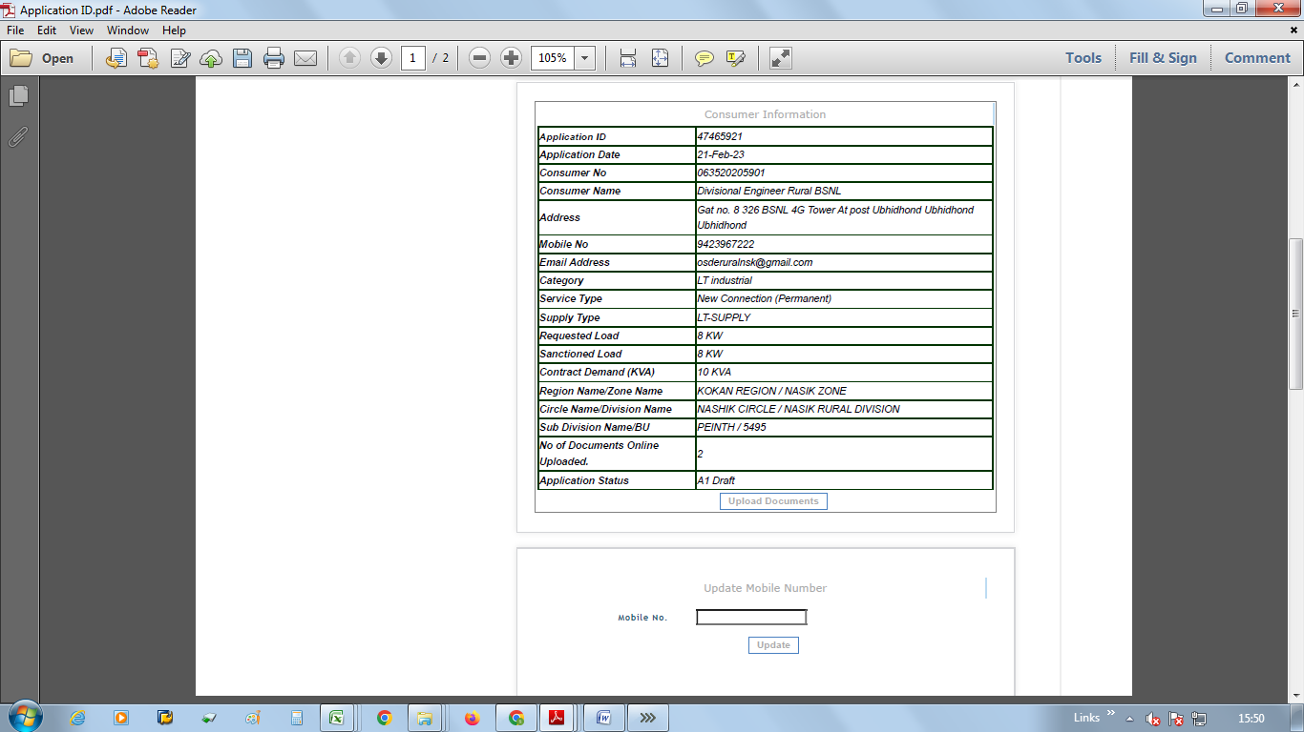

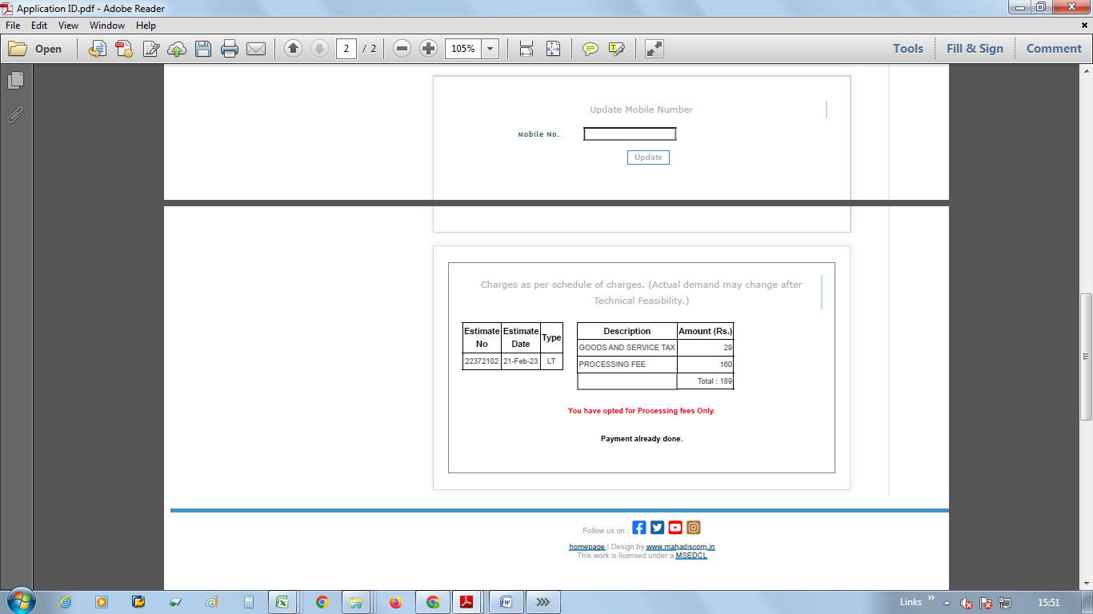

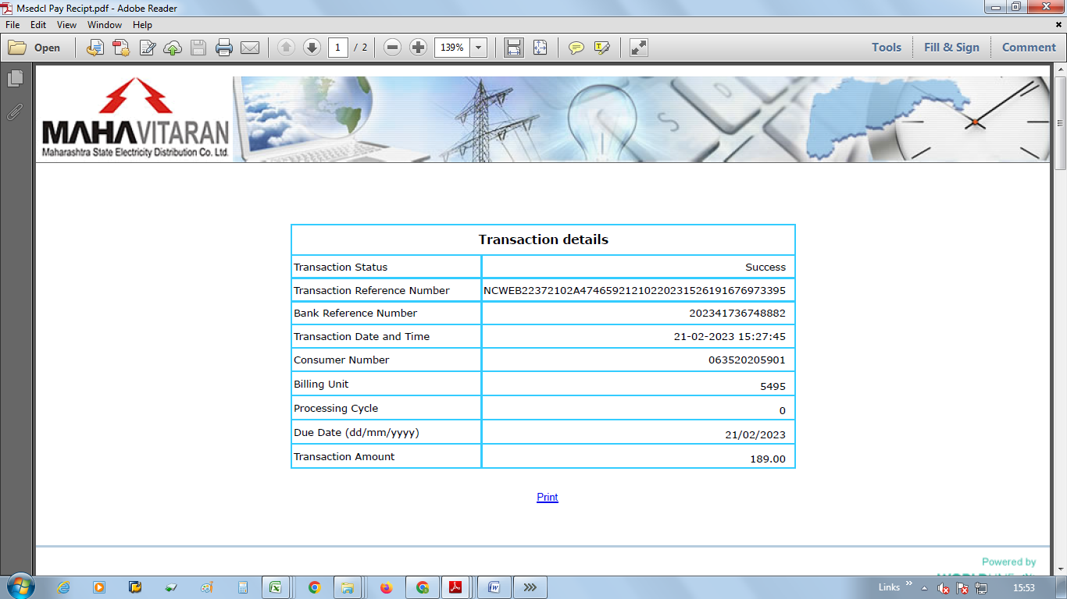

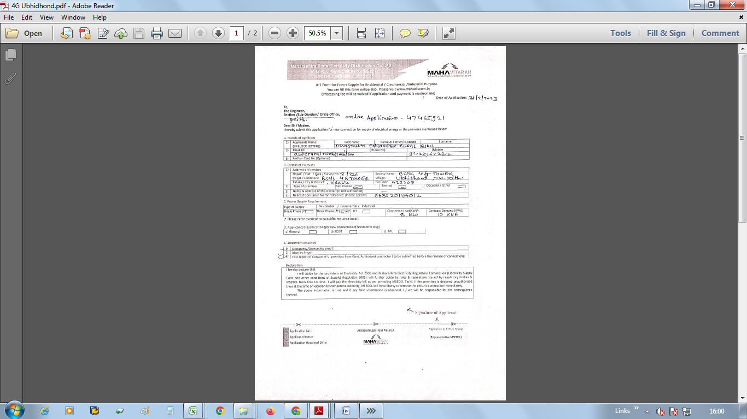

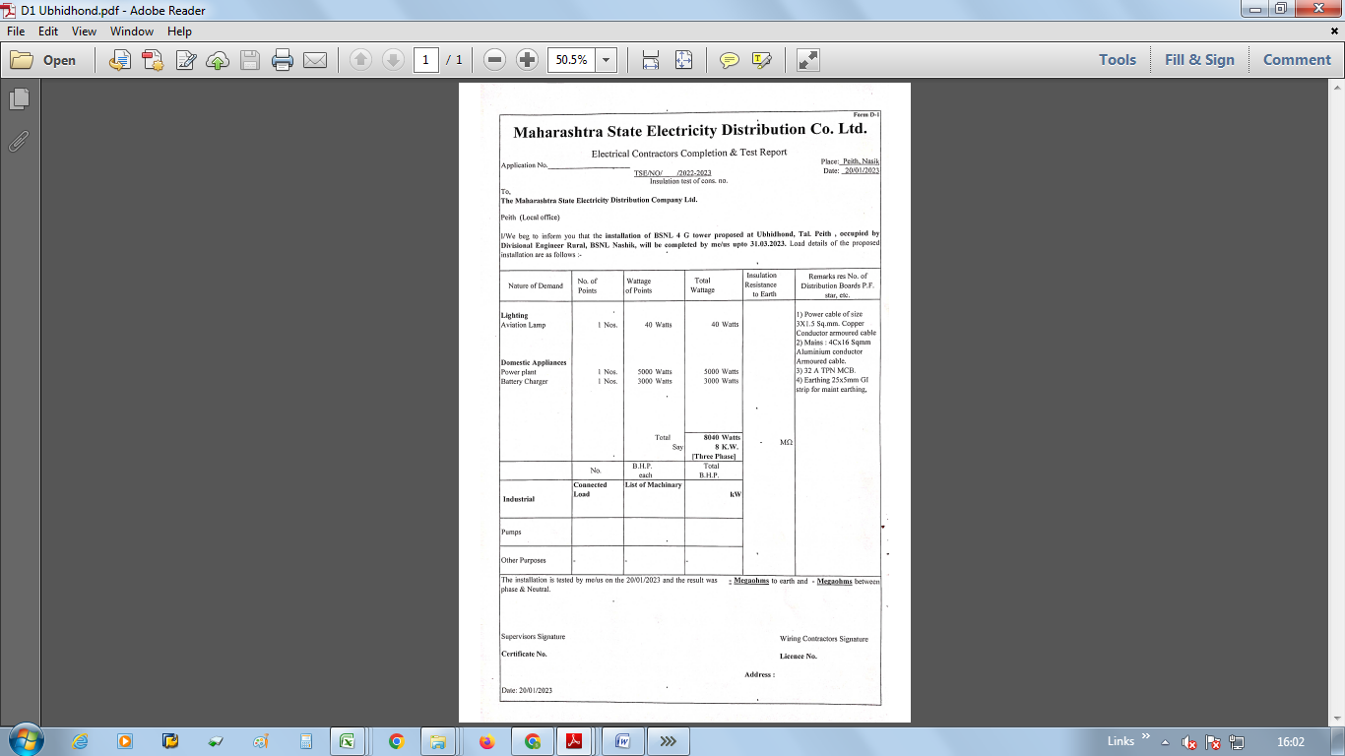

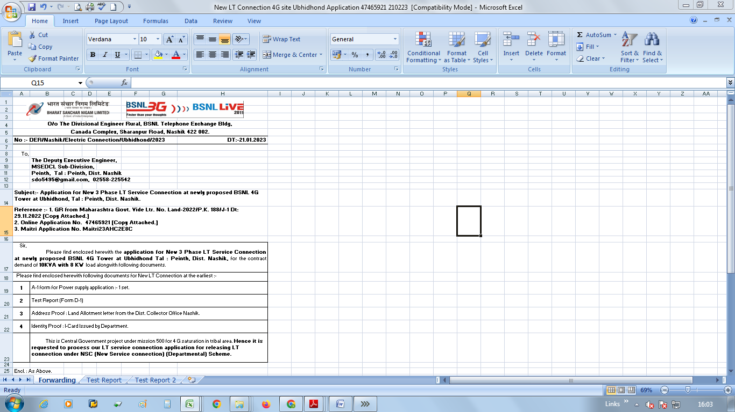

Submit the application with forwarding letter and its supporting documents to the respective sub-Division office of the MSEDCL.